Pirate’s Cove Waterpark – Pohick Bay Regional Park – Big Splash Birthday Party

The Big Splash Party at Pirate’s Cove Waterpark is offered 7 days a week during the waterpark season only.

Rental Block: 11:30 am – 1:30 pm 2:00 pm – 4:00 pm 4:30 pm – 6:30 pm

$22.00 per child-Maximum 25 – Minimum of 10 must be paid at the time the reservation is made.
10% discount on your basic party, add-ons not included, for reservations on Monday – Thursday
Not applicable on holidays.

Pirate’s Cove Waterpark offers two birthday areas for Big Splash parties. The Crow’s Nest, Pirate’s Cove’s original birthday facility, is located within close proximity to the pool and Captain’s Galley concessions area, on a raised wooden platform extending off the pool deck. Blackbeard’s Cay, the newest birthday area, is located next to the giant water slides and offers a more private setting. Both facilities offer adequate seating and a shade structure to keep you and your guests cool on a great summer day.

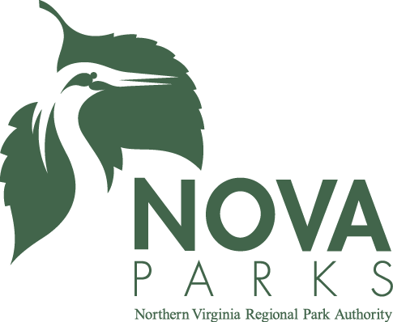

Big Splash Party Includes:

- Admission to Pirate’s Cove Waterpark ALL DAY!
- Private party area for 2 hours
- Free Chaperone for each guest under 12 years old (food not included)
- Personal party assistant for duration of party
- Gift/Cake cart to use during party
- Special gift for birthday child
- Valuable coupon for all birthday guests
- 2 slices of pizza per guest
- Drinks – soda, juice or milk
- Ice Cream
- Plates, napkins, utensils
- Printable Invitation

Add-on additional pizzas, Dippin’ Dots and other items
- Pizza $12 each
- Ice Cream $2 each
- Drink Pitcher $5 each
- Dippin’ Dots $3.50 each
Please review the Birthday Reservation Rules prior to making your reservation.

