Ocean Dunes Waterpark – Upton Hill Regional Park – Big Splash Birthday Party

The Big Splash Party at Ocean Dunes Waterpark is offered 7 days a week during the waterpark season only.

Rental Block: 11:00 am – 1:00 pm 2:00 pm – 4:00 pm 5:00 pm – 7:00 pm

$22.00 per child-Maximum 25 – Minimum of 10 must be paid at the time the reservation is made.
10% discount on your basic party, add-ons not included, for reservations on Monday – Thursday
Not applicable on holidays.

Ocean Dunes offers two birthday areas for Big Splash parties. Both the Cove and the Nook are conveniently located adjacent to the snack bar and Splash Pad. Each area has picnic tables and a large shade structure to keep you and your guests cool on a great summer day.

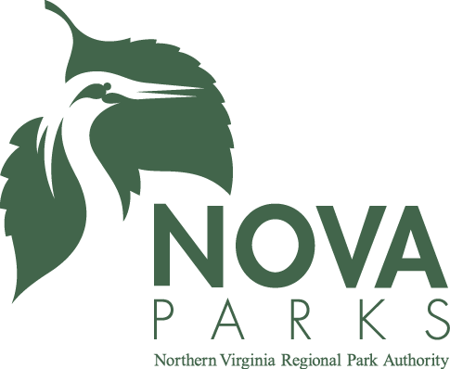

Big Splash Party Includes:

- Admission to Ocean Dunes Waterpark ALL DAY!
- Use of mini-golf and batting cage ALL DAY!
- Private party area for 2 hours
- Free Chaperone for each guest under 12 years old (food not included)
- Personal party assistant for duration of party
- Gift/Cake cart to use during party
- Special gift for birthday child
- Valuable coupon for all birthday guests
- 2 slices of pizza per guest
- Drinks – soda, juice or milk
- Ice Cream
- Plates, napkins, utensils
- Printable Invitation

Add-on additional pizzas, Dippin’ Dots and other items
- Pizza $12 each
- Ice Cream $2 each
- Drink Pitcher $4 each
- Dippin’ Dots $3.50 each
Please review the Birthday Reservation Rules prior to making your reservation.

