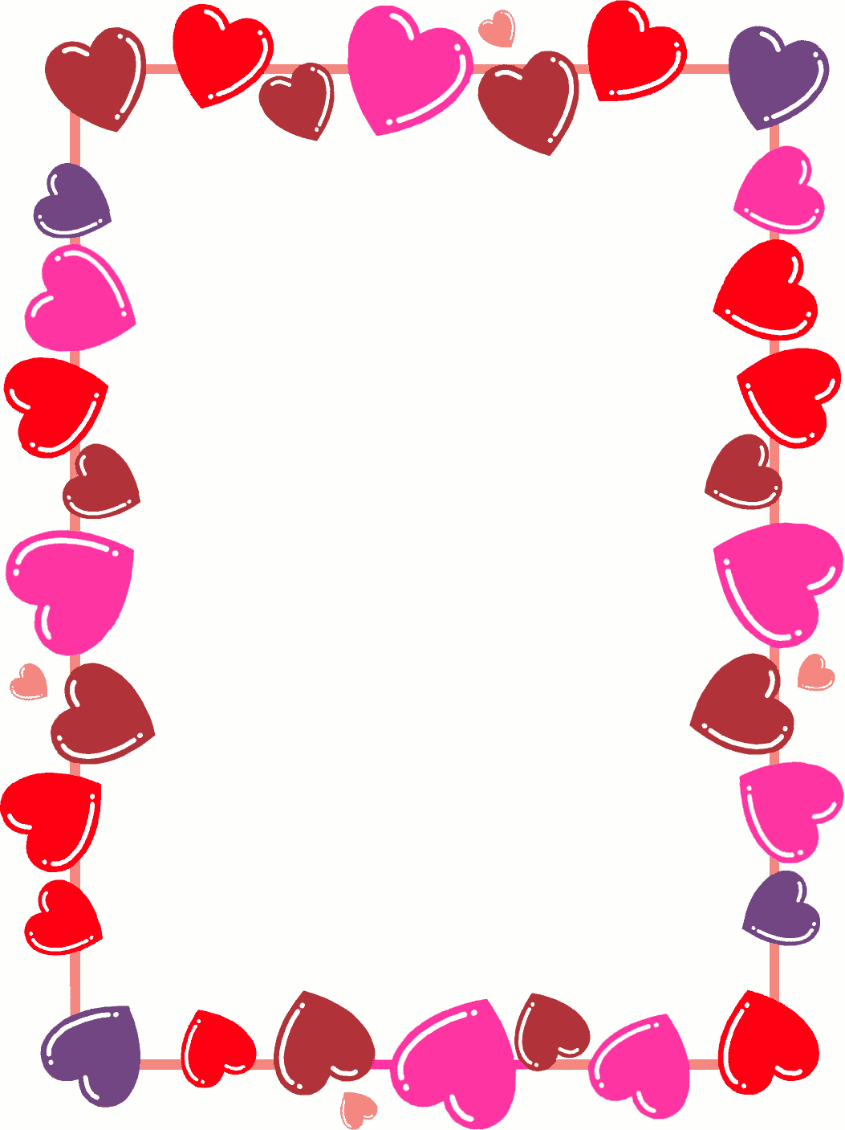

**Valentine’s Day**

**Craft Kit**

Contents:

* Hand warmer sewing project
* Heart wreath art project
* Marble painting Valentine cards
* Candy making gift kit
* Bird feeder craft

**Kit is appropriate for kids ages 6-12**

Delivered to your home (Apple Valley residents only) on February 1st. Live outside of Apple Valley? You can pick your kit up at the Apple Valley Community Center any day after February 1st.

